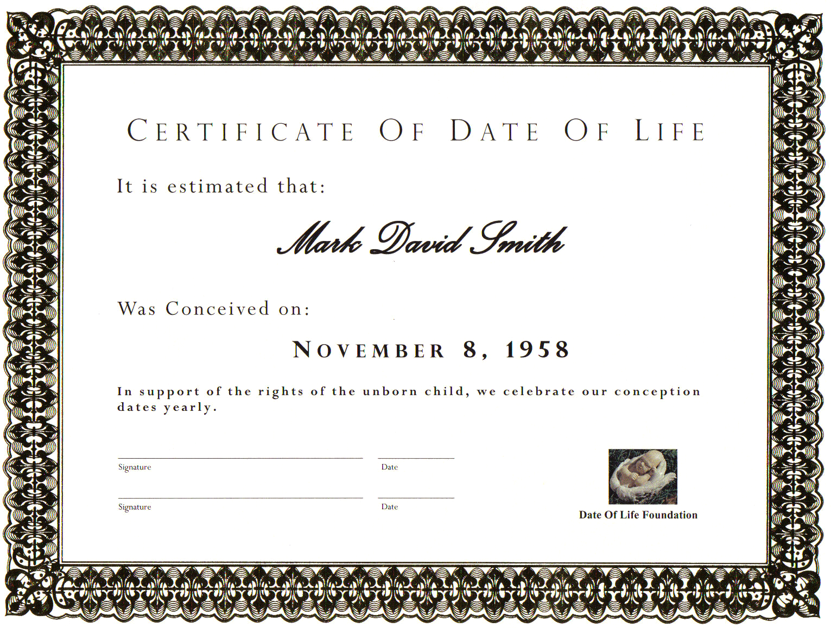
Put your Name Here
Estimated Date of Life

